Thermal Crosstalk Simulator for Passive Crossbar Arrays of Memristive Devices
Alana Bestaeva⁽¹⁾, Daniel Schön⁽¹⁾, Kristina Nikiruy⁽²⁾, Martin Ziegler⁽²⁾ and Stephan Menzel⁽¹⁾
⁽¹⁾ Research Centre Jülich (PGI-7), ⁽²⁾ CAU Kiel (Department of Materials Science)
Thermal crosstalk in passive crossbar arrays of memristive devices is typically considered a parasitic effect that degrades switching accuracy and device reliability. However, temperature can also be interpreted as an additional state variable, enabling novel computational approaches such as thermally assisted or thermal computing.
In this work, we present a numerical simulation framework for the analysis of thermal crosstalk in passive memristive crossbar arrays. The proposed simulator computes Joule heating in an addressed cell and calculates the resulting spatiotemporal temperature distribution across the array. Device-to-device thermal coupling and heat propagation through the substrate and interconnects are explicitly considered.

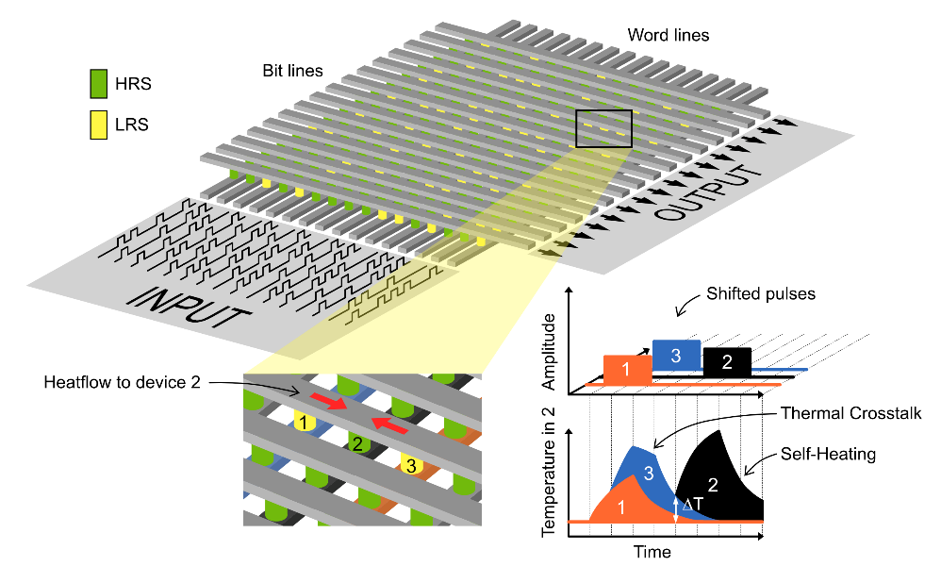
Figure 1: Pulse application and heat response in a passive crossbar array
The developed simulation framework provides valuable insight into the thermal response and heat distribution within memristive arrays, offering a deeper understanding of thermally induced interactions. Such insights are particularly relevant for researchers exploring thermally driven computing concepts. For instance, in applications like associative learning, controlled thermal coupling between devices can be leveraged as an additional mechanism for information processing. The presented simulator therefore serves as a useful tool for analyzing and guiding the design of systems that aim to exploit thermal effects for computation

This research was performed as part of the MemCouple project, funded by the German Research Foundation (DFG).
- D. Schön et al., IEEE Electron Device Letters, vol. 46, no. 11, pp. 2018-2021, Nov. 2025
- D.Schön, S.Menzel, Advanced Functional Materials, 33(22), 2213943, 2023

