Selector-Only Mott Memory for Spike-driven Hardware Security and Combinatorial Optimization
Gwangmin Kim⁽¹⁾ and Stephan Menzel⁽¹⁾
⁽¹⁾ Peter-Grünberg-Institut 7 (PGI-7), Forschungszentrum Jülich GmbH, 52425 Jülich, Germany
The Compute Express Link (CXL) standard has spurred the emergence of new memory classes such as selector-only memory (SOM), which is primarily designed for storage via selector’s threshold-voltage modulation.[1] As data-intensive modern computing increasingly demands processing-in-memory (PIM), extending SOM beyond storage and toward computing could provide a promising route to overcoming the von Neumann bottleneck issue. Here, we propose an NbO_{x}-based selector-only Mott memory (SOMM) and demonstrate its crossbar-array implementation of two physical computing primitives: a physical unclonable function (PUF) and simulated annealer (SA). The SOMM enables direct transduction of analog resistance of each cell into multi-bit digital outputs via spike counts, bypassing energy-intensive signal-domain conversion circuitry. The proposed PUF achieves 2^{N} – 1 challenge-response pairs for an N-cell array, with inherent concealability and reconfigurability for stronger hardware security. In the SA, the intrinsic thermal noise physically drives the annealing process, achieving 10⁵-fold reduction in energy consumption compared with state-of-the-art GPUs.[2] Collectively, these results highlight SOMM as a versatile computing template for next-generation PIM hardware.

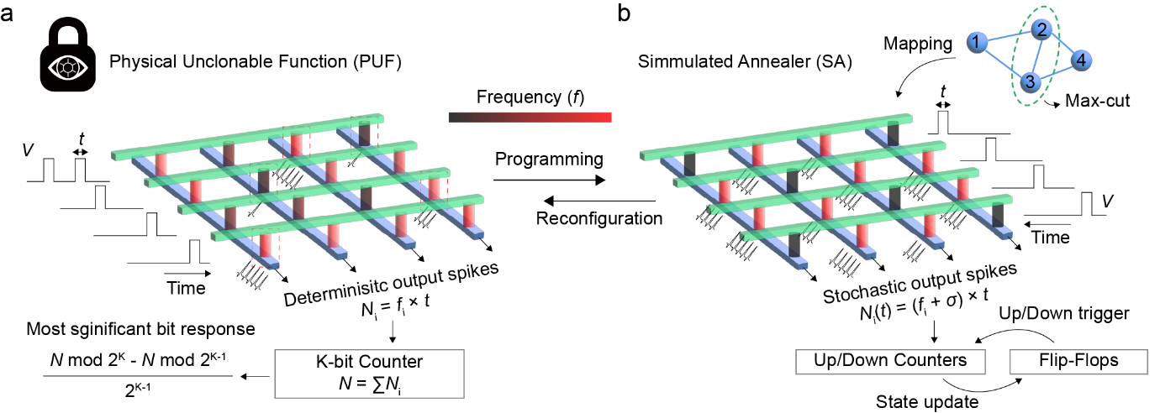
Fig. 1 | The physical unclonable function (PUF) and simulated annealer (SA) based on selector-only Mott memory (SOMM) passive crossbar array. a An illustration of a PUF utilizing deterministic spike counts. Intrinsic cell-to-cell variations induce diverse spike counts, which are accumulated in a K-bit counter. b An illustration of a SA driven by stochastic spike counts. A graph is mapped onto a crossbar array where the stochasticity is controlled by time. Both systems operate without external signal domain conversions.

- Hong, S. et al., IEDM, 18.16.11-18.16.14, 2022.
- Cai, F. et al, Nat. Electron., 3, 409-418, 2020.

