Si/SiGe Quantum Well Transistor Emulating Biological Synaptic Plasticity for Energy-Efficient Neuromorphic Computing

A. Rajan⁽¹⁾ , J. Zhang⁽¹⁾,Y. Liao⁽¹⁾, J. Sun⁽¹⁾, D. Grützmacher⁽¹⁾, A. Mai^{(2,3)} , Y. Yamamoto^{(2,4)} ,Q. -T. Zhao⁽¹⁾.
⁽¹⁾ Peter Grünberg Institute (PGI-9) Forschungszentrum Jülich, Jülich, Germany, ⁽²⁾ IHP-Leibniz Institute for High Performance Microelectronics, Frankfurt(oder), Germany, ⁽³⁾ Technische Hochschule Wildau, Wildau, Germany, ⁽⁴⁾ Nagoya University, Nagoya, Japan.
As artificial intelligence continues to scale, the energy gap between conventional von Neumann hardware and biological neural systems has become one of the most pressing challenges in modern computing. Si/SiGe quantum well (QW) transistor with a vertical architecture was reported as an artificial synapse using TCAD simulations [1] and as cryogenic electron-based flash memory [2]. In this work, we experimentally demonstrate a planar Si/Si₀.₈Ge₀.₂/Si QW Schottky barrier MOSFET (SB-MOSFET) as an artificial synapse. The valence-band offset of 148 meV at the Si/SiGe interface forms a buried QW, enabling controlled hole trapping and de-trapping for programmable conductance modulation. A positive gate bias drives hole accumulation into the QW raising channel conductance during reading, while a negative gate bias depletes trapped holes, yielding a nonvolatile and tunable synaptic weight state.
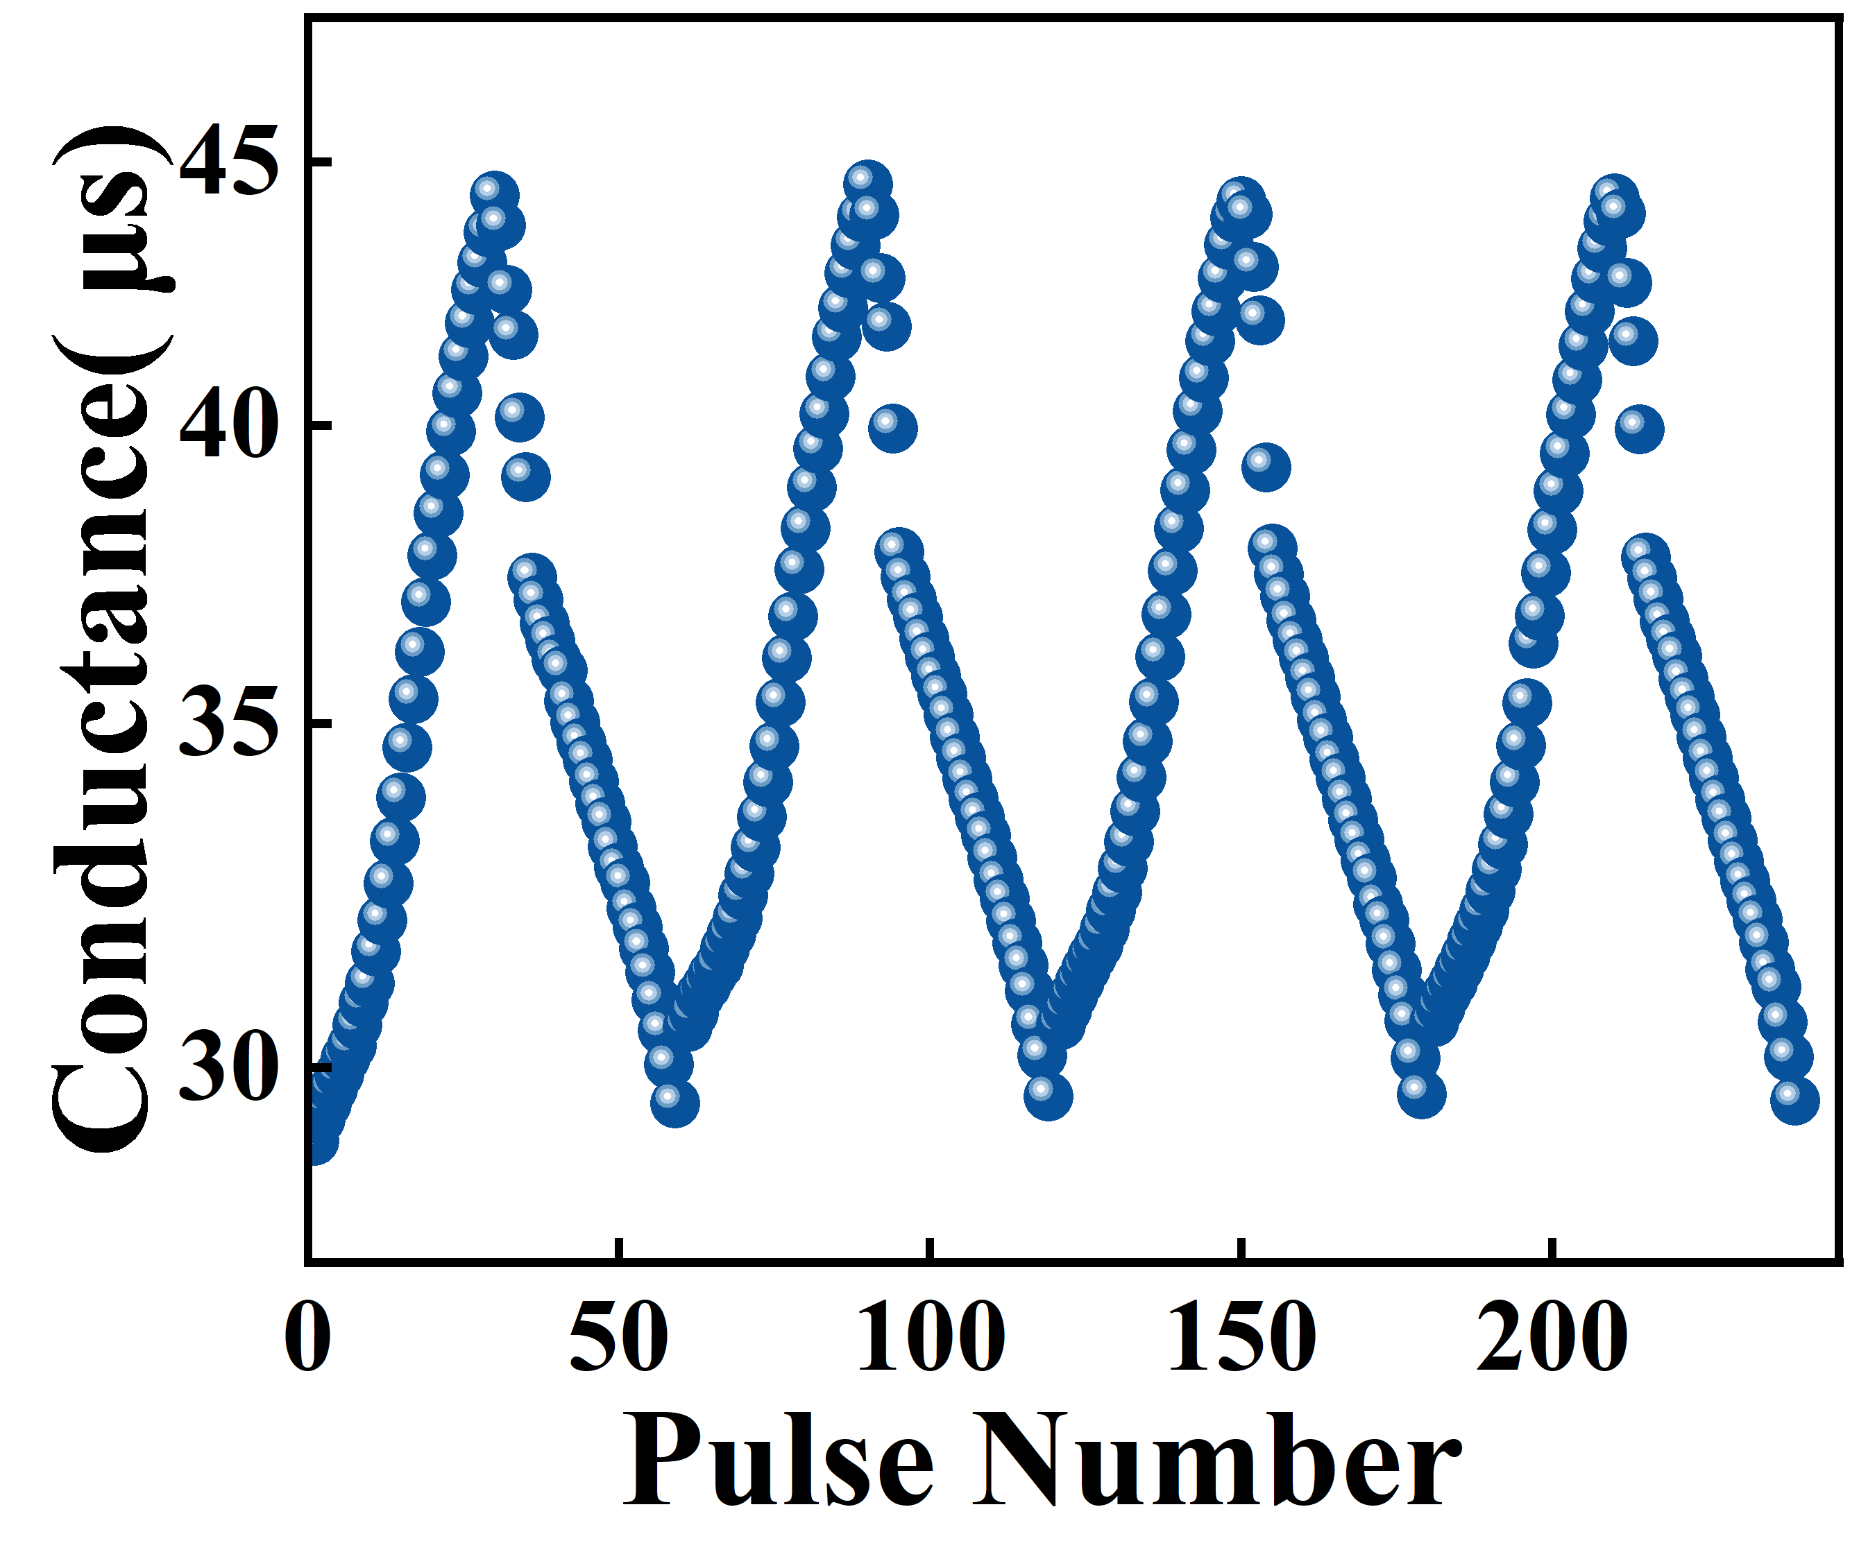
Figure 1: Long-term potentiation/depression of the synapse by measuring the conductance of the transistor as a function of pulse number, demonstrating good linearity, high symmetry and very small cycle-to-cycle variation.

A heterostructure comprising a 15 nm slightly phosphorous doped Si cap, a 20 nm boron-doped Si₀.₈Ge₀.₂ layer (~10¹⁷ cm⁻³) was grown by reduced pressure CVD on a Si substrate, using H₂-SiH₄ and H₂-SiH₄-GeH₄ gas mixtures, respectively. The device was fabricated with a CMOS process using HfO₂ as gate dielectric and nickel disilicide (NiSi₂) as source and drain Schottky contacts. We demonstrate that a single transistor can be operated as a short-term memory by writing with a high gate voltage .The memory shows retention time of one hour at room temperature and a high endurance. The device also characterized as an artificial synapse. The short-term plasticity and long-term plasticity are successfully emulated through constant-amplitude and stepwise increasing gate voltage pulse schemes. The measured potentiation and depression as shown in Fig.1 indicate good linearity and symmetry, as well as low cycle-to-cycle variation. The device shows high-energy efficiency with a low energy consumption of 0.8 pJ/spike, confirming Si/SiGe QW SB-MOSFETs as viable CMOS building blocks for energy-efficient neuromorphic hardware.
[1] S. Y. Woo et al., IEEE Trans. Electron Devices, 67(9), 3832–3838, 2020.
[2] W. C. Hou et al., ACS Appl. Electron. Mater, 4(6), 2879–2884, 2022

