Vanadium Dioxide as a Single-Material Platform for Neuromorphic Chips
Alexandre Zimmers⁽¹⁾
⁽¹⁾ LPEM, ESPCI Paris, PSL Research University, Sorbonne Université, CNRS - France

The brain-inspired algorithms of the AI revolution primarily run on conventional silicon computer architectures that were not designed for this purpose. This could soon lead to unsustainable energy consumption as AI continues to grow. Neuromorphic devices offer the promise of lower energy consumption by mimicking the brain’s basic components—neurons and synapses—ideally using a single material. Unfortunately, among the few quantum materials that naturally act as spiking "neuristors" (artificial neurons), non-volatile synaptic memory (artificial synapses) has been hard to implement. One promising candidate functioning at room temperature is vanadium dioxide (VO₂). Interestingly, this material exhibits multiscale fractal electronic patterns during its insulator-metal transition, which must be understood and controlled before it can be fully used in single-material neuromorphic devices.
To achieve this, we have developed a new optical microscopy method that allows for the precise submicron mapping of these insulator-metal patterns [1] (see Figure 1c). More recently, by using various temperature sweeps [2], a focused laser beam, and an AFM scanning tip [3] (see Figure 1e), we have been able to modify and write specific insulator-metal patterns in the material. These findings could enable rewritable synaptic connections between neuristors within a single VO₂-based neuromorphic chip.

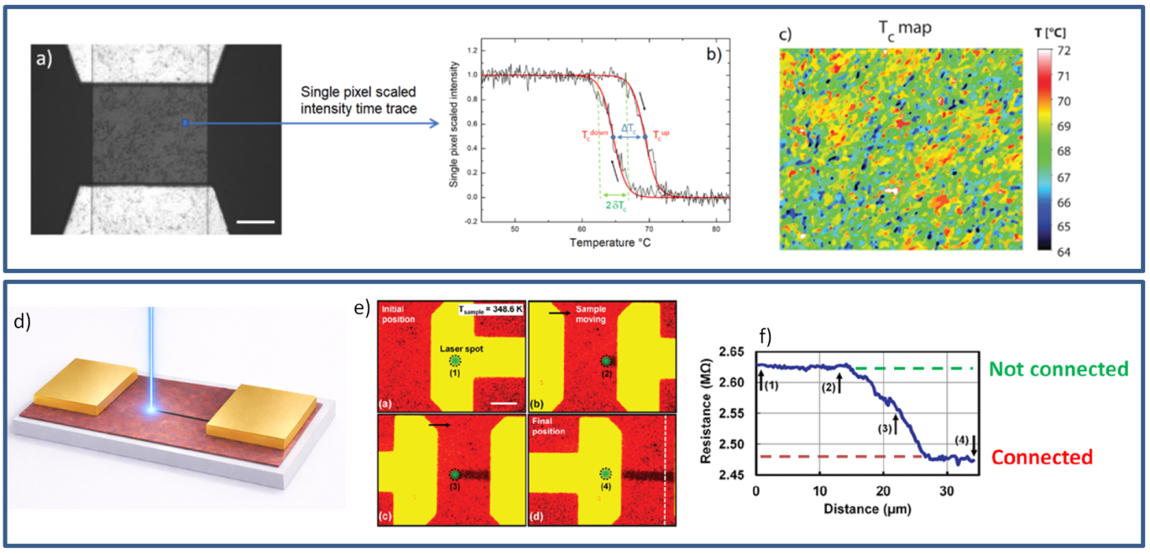

Figure 1: (a) 30×35 µm area of the VO₂ surface (gray area). (b) Reflectivity vs. temperature of a signal pixel. (c) Critical temperature (Tc) map [1].
(d) Schematic of a metallic synaptic link encoded by laser. (e) False-color image of the VO₂ surface during laser writing. (f) Resistance drop as the metallic path is written [3].

[1] Condens. Matter , 10, 12, https://doi.org/10.3390/condmat10010012 (2025)
[2] Adv. Electron. Mater., 9, 2300085, https://doi.org/10.1002/aelm.202370046 (2023)
[3] Adv. Electron. Mater., 11, 2400249, https://doi.org/10.1002/aelm.202400249 (2024)

